**DBMS LAB PROJECT**

**ONLINE INVENTORY SYSTEM**

**KEY MILESTONE 03**



## CSE403L Database Management System Lab

Group members

**Arsalan khan (22PWCSE2110)**

**Waseem (22PWCSE2179)**

**Adnan Zeb (22PWCSE2191)**

Class Section: **A**

“On my honor, as student of University of Engineering and Technology, I have neither given nor received unauthorized assistance on this academic work.”

Student Signature:

Submitted to:

## Engr.Sumayyea Salahuddin

(JUNE 02, 2025)

Department of Computer Systems Engineering

University of Engineering and Technology, Peshawar

**Tables and Metadata**

1. **users**

* **Primary Key**: id
* **Attributes**: name, email, username, password, photo
* **Purpose**: Stores system user data (admin/staff)

2. **suppliers**

* **Primary Key**: id
* **Attributes**: name, email, phone, address, shopname, type, bank_name, account_holder, account_number, photo
* **Purpose**: Stores supplier details

3. **customers**

* **Primary Key**: id
* **Attributes**: name, email, phone, address, type, bank_name, account_holder, account_number, photo
* **Purpose**: Stores customer information

4. **categories**

* **Primary Key**: id
* **Attributes**: category_name
* **Purpose**: Defines product categories

5. **units**

* **Primary Key**: id
* **Attributes**: unit_name
* **Purpose**: Defines measurement units (e.g., kg, pcs)

6. **products**

* **Primary Key**: id
* **Foreign Keys**: category_id → categories(id), unit_id → units(id)
* **Attributes**: product_name, product_code, buying_price, selling_price, stock, product_image
* **Purpose**: Stores product details

7. **purchases**

* **Primary Key**: id
* **Foreign Keys**: supplier_id → suppliers(id), created_by → users(id), updated_by → users(id)
* **Attributes**: purchase_date, purchase_no, purchase_status
* **Purpose**: Records purchase transactions

8. **purchase_details**

* **Primary Key**: (purchase_id, product_id)
* **Foreign Keys**: purchase_id → purchases(id), product_id → products(id)
* **Attributes**: quantity, unitcost, total
* **Purpose**: Stores line items of each purchase

9. **orders**

* **Primary Key**: id
* **Foreign Key**: customer_id → customers(id)
* **Attributes**: order_date, order_status, total_products, sub_total, vat, total, invoice_no, payment_type, pay_int, due_int
* **Purpose**: Stores customer orders

10. **order_details**

* **Primary Key**: (order_id, product_id)
* **Foreign Keys**: order_id → orders(id), product_id → products(id)
* **Attributes**: quantity, unitcost, total
* **Purpose**: Stores line items of each order

**Queries**

1. **Products with category and unit**

SELECT p.product_name, c.category_name, u.unit_name

FROM products p

JOIN categories c ON p.category_id = c.id

JOIN units u ON p.unit_id = u.id;

1. **Customers and order count**

SELECT name, COUNT(id) AS total_orders

FROM customers c

JOIN orders o ON c.id = o.customer_id

GROUP BY c.id**;**

1. **Total purchases by supplier**

SELECT s.name, COUNT(p.id) AS total_purchases

FROM suppliers s

JOIN purchases p ON s.id = p.supplier_id

GROUP BY s.id;

1. **Order details**

SELECT product_id, quantity, unitcost, total

FROM order_details

WHERE order_id = 1;

1. **Total revenue**

SELECT SUM(total) AS total_revenue FROM orders;

1. **Top 5 selling products**

SELECT product_id, SUM(quantity) AS sold

FROM order_details

GROUP BY product_id

ORDER BY sold DESC

LIMIT 5;

**7. Low stock products**

SELECT product_name, stock FROM products WHERE stock < 10;

**SQL Implementation**

**Code**

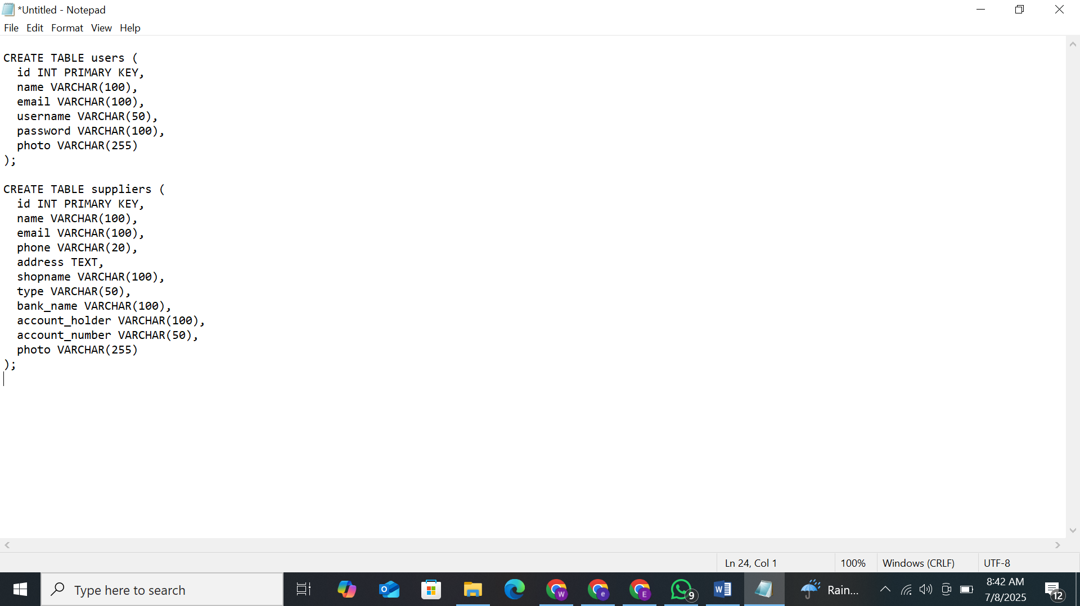

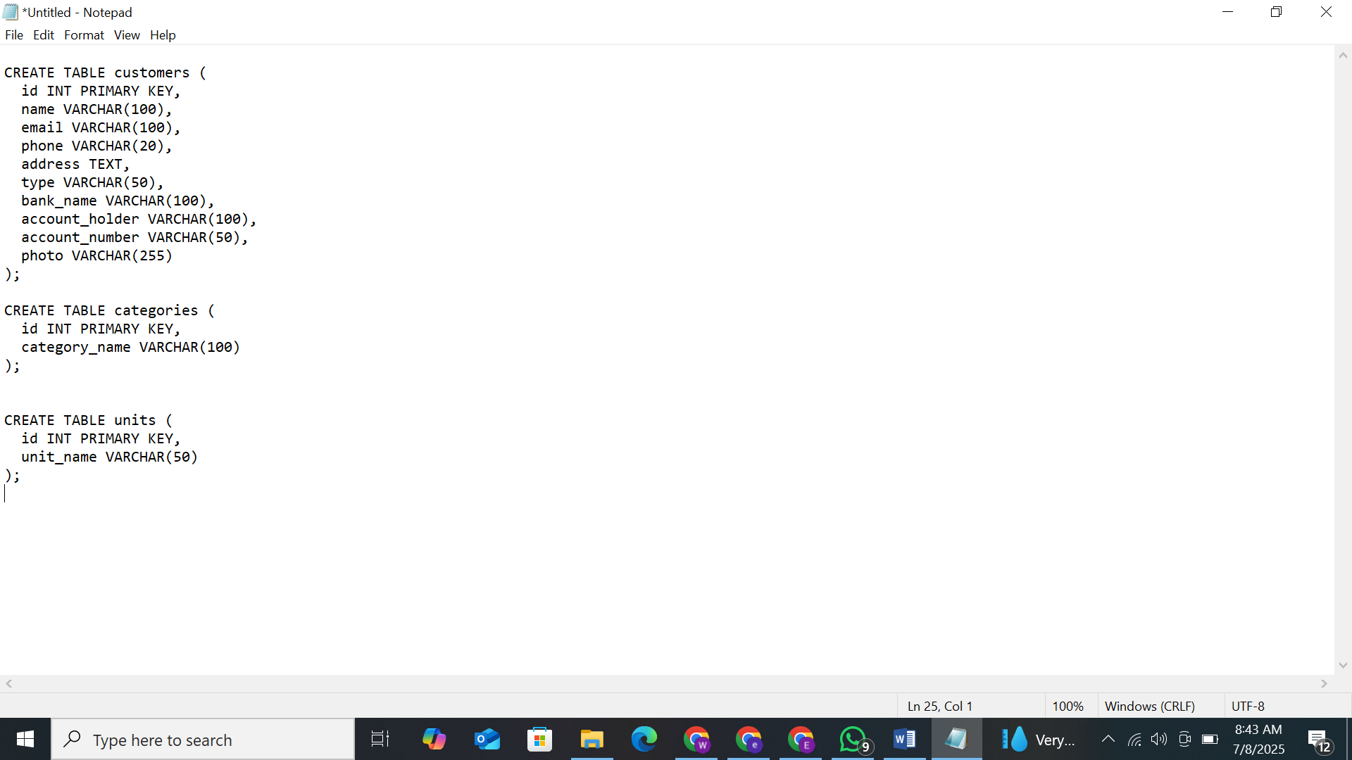





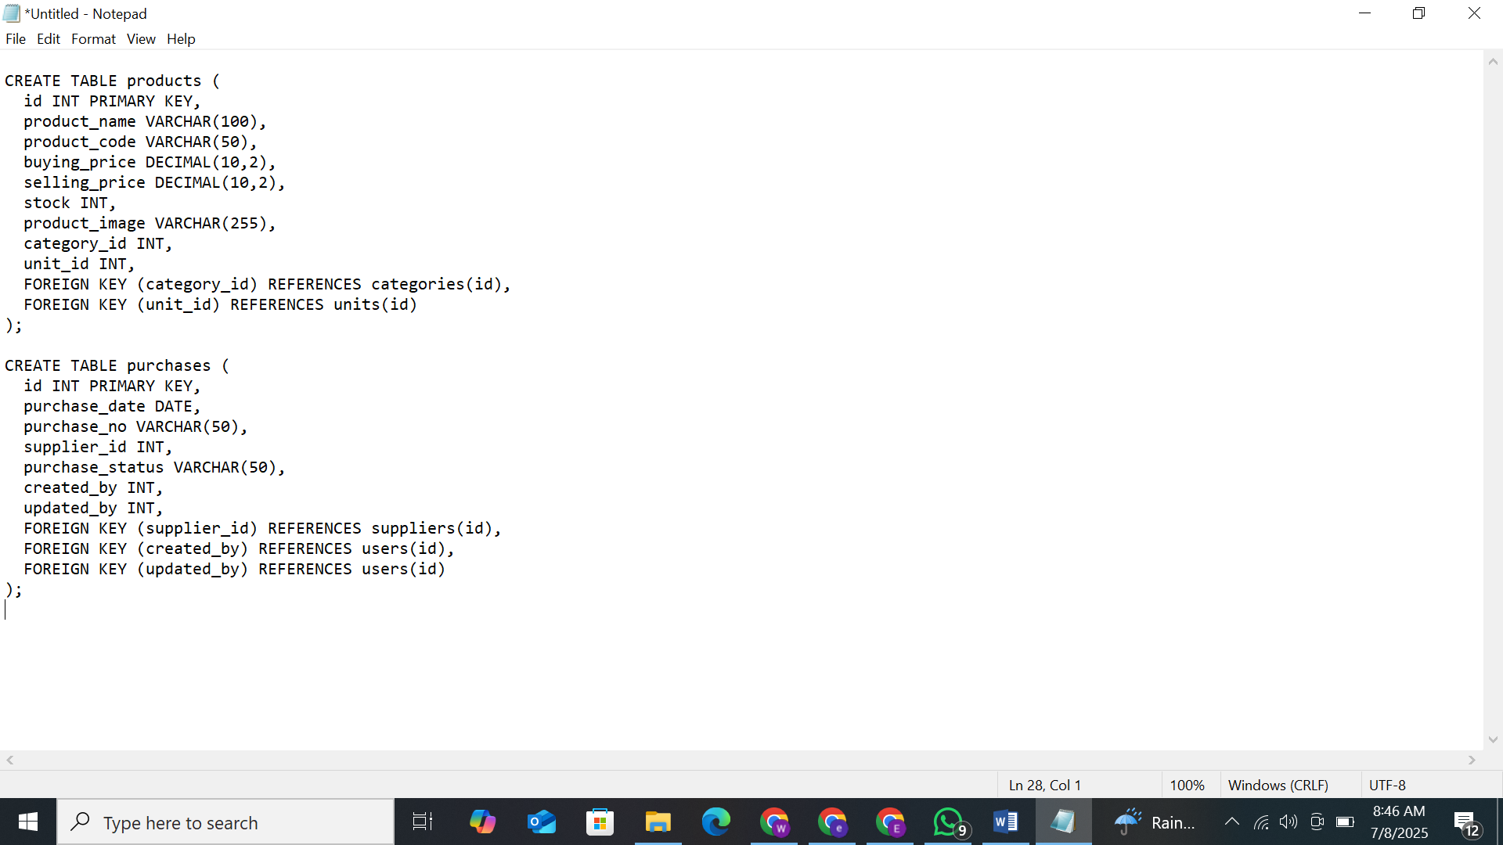



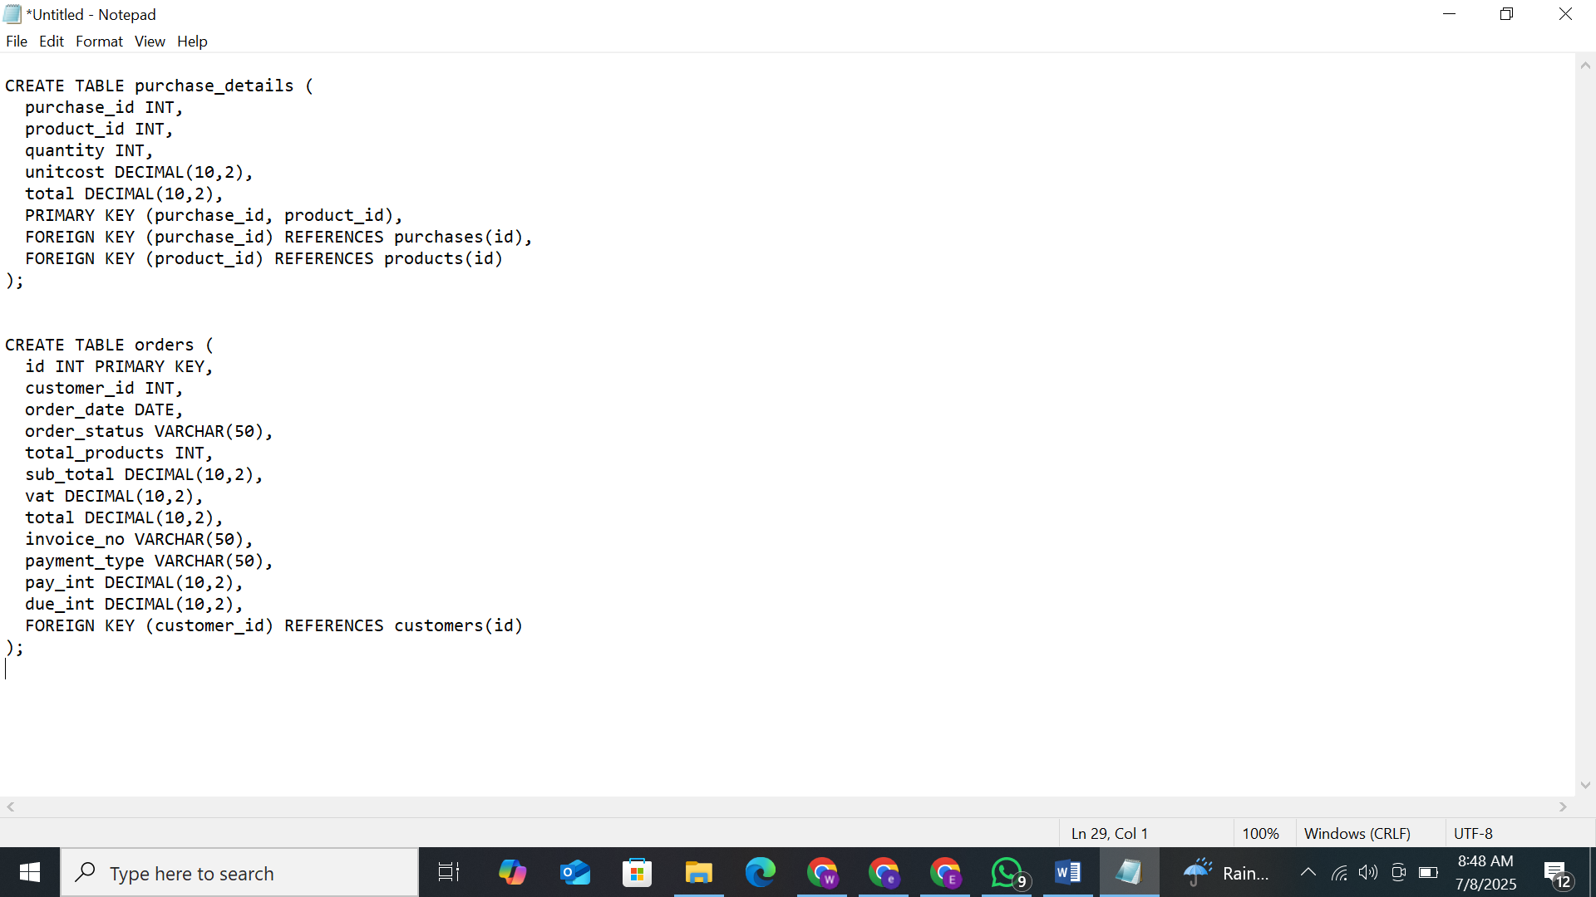



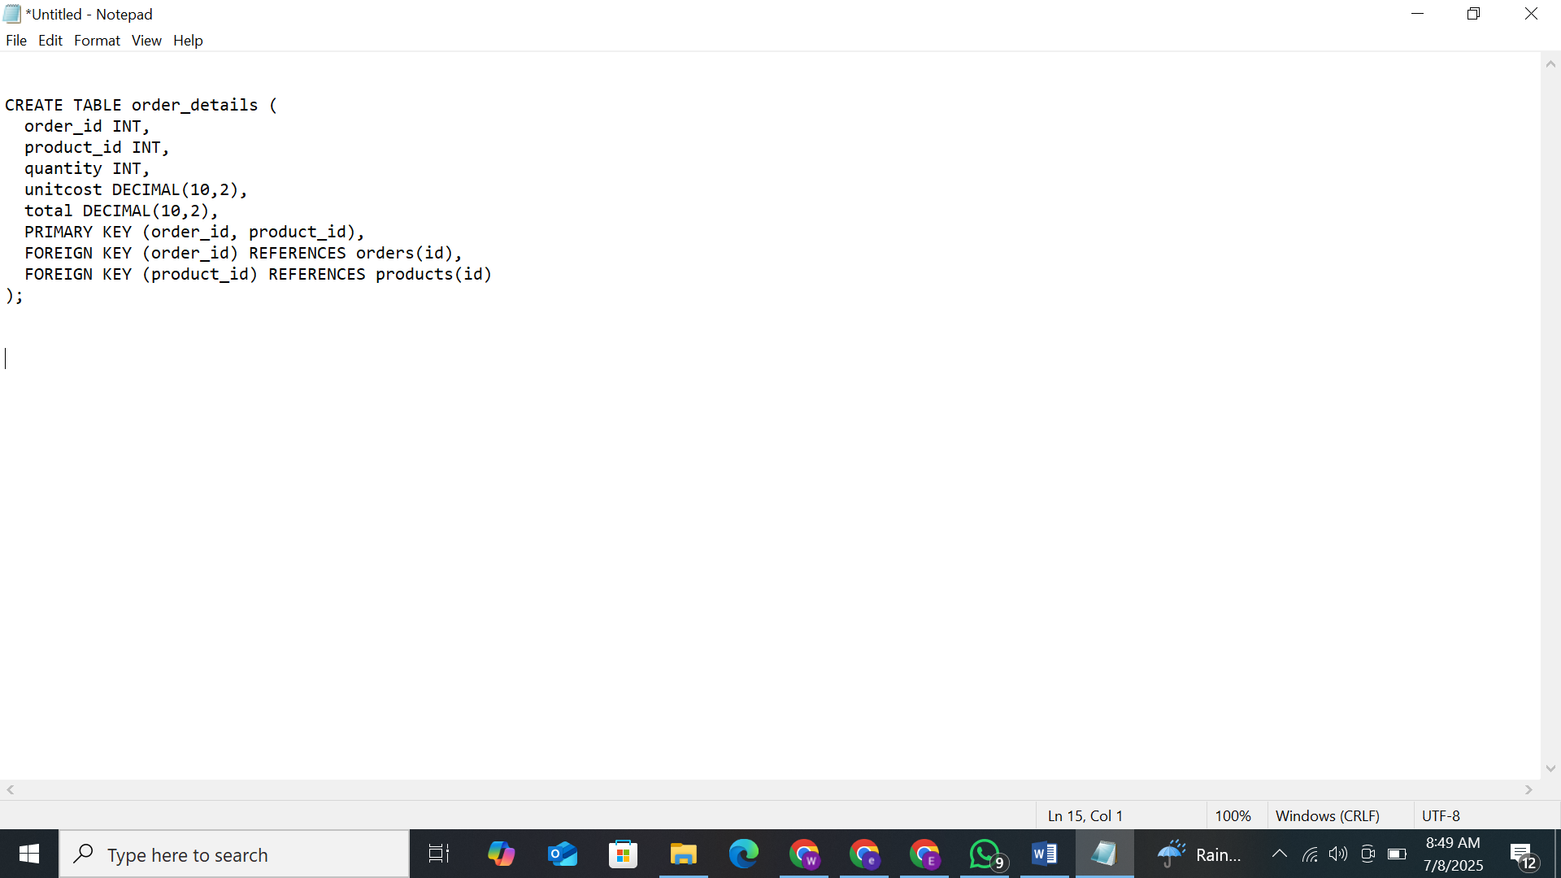

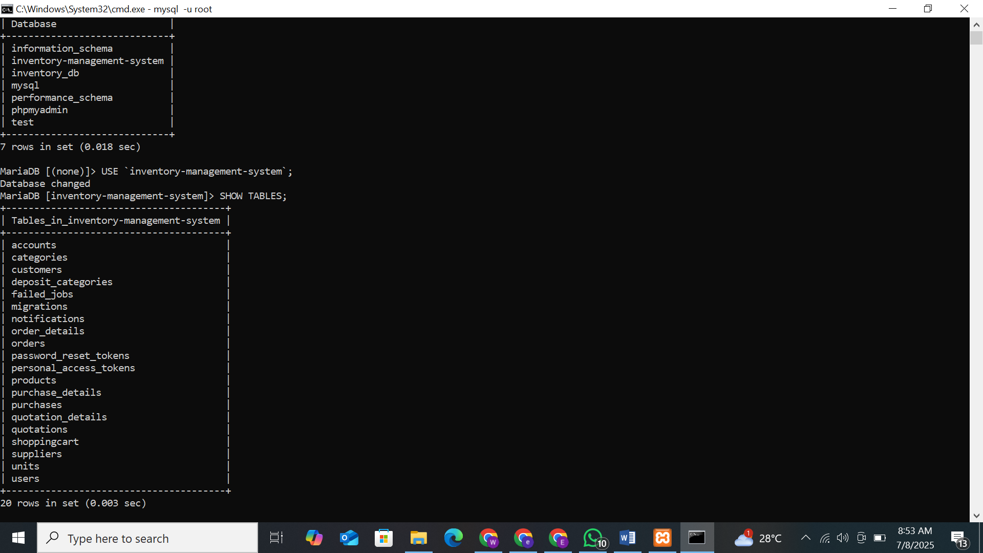

**Refrence:**

https://chatgpt.com/c/686caf0d-040c-8003-a9fc-7925c299c3fc

https://github.com/fajarghifar/inventory-management-system